E-Commerce Project

1. Snip of Sales & Profit Report:

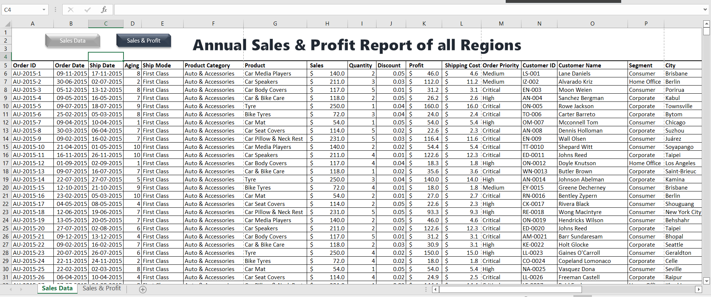

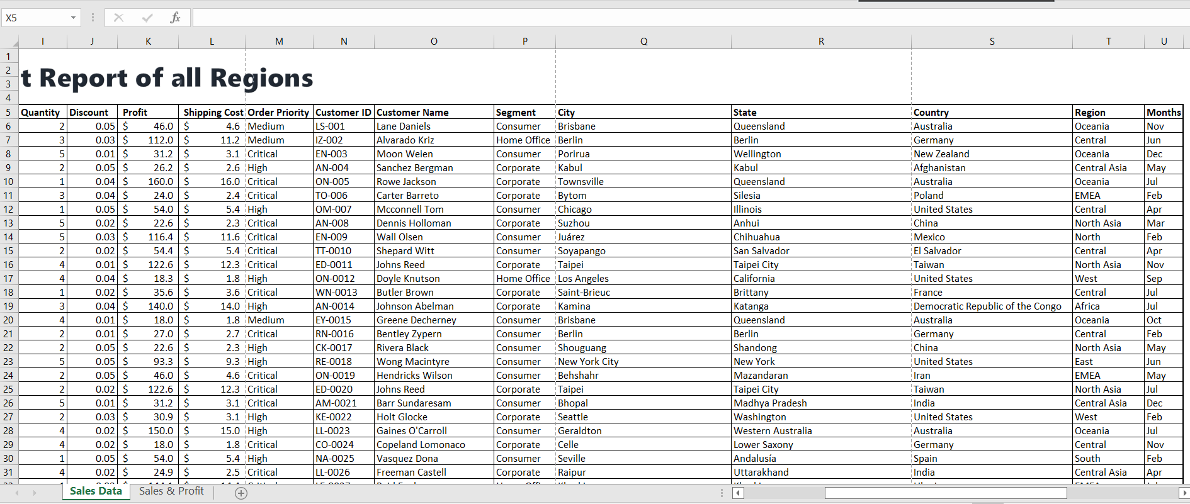

1. Snip of Annual Performance of E-comm Products of all Region:

